CONSCIOUS CONSUMERS OF FUTURE

LESSON PLAN

**The world around us - environment -**

**Description**: a lesson for the 11º year of upper secondary school (students’ age 15/16) about unsustainable consumption and threats.

**Time**: 2 lessons (2 x 60 minutes)

|  |
| --- |
| **English Lesson Plan** |

|  |  |
| --- | --- |
| Subject: **Environment** | Class: **11th A** |
| Contents: **Environmemtal Issues**  **Aims**  By the end of the lesson learners will be able to:  • understand important causes, problems and consequences of environmental issues and some solutions  • extend their understanding of lexis connected to climate change and environmental issues  • improve understanding of pronunciation information given  • take notes and retell information to others  • provide an opportunity for free speaking practice  • develolp integrated skills: listening, speaking | Date: **April 2018** |
| Professora : Isabel Negrão | |

|  |
| --- |
| Summary: The world around us - developing listening and speaking skills. |

|  |
| --- |
| **Step 1**  Ss watch a commercial without sound <https://www.youtube.com/watch?v=zMvWGT6l3lI>  T elicits from ss its content  Ss recount the ad : a father reads a bed time story, it's about environment, animals in danger, floods, ...  T writes on the board what ss say  Ss watch the commercial again, now with sound to confirm their ideas  T + ss organise them under the headings (e.g. problems, causes, consequences, solutions,....)  **Step 2**  T- Whose birthday is it today? Is it yours, .....?  S answers  T asks someone else, again.  S asks  T asks : Whose birthday is it on the 22 nd of April?  Ss try to guess  T shows a picture (picture A)  T asks ss some questions:  - When was the 1st Earth Day celebrated?  - How old is Earth Day?  - Why do people celebrate Earth Day?  - In Portugal, how do people celebrate Earth Day?  - In our school do we usually celebrate Earth Day? Why?/Why not?  - What activities could we do to celebrate Earth Day?  - What do you think future generations may think about today's generations' actions towards the state of our planet?  - What is your opinion about the previous generations' actions towards the state of the planet?  T asks ss to complete the sentence with just one word ... "Dear future generations________!  Ss share their answers  T asks ss: Who is Prince Ea?, What do you know about him? (Picture B)  T writes on the board 3 questions and asks students to pay attention to the message:    - **Who is the singer addressing to?** *(generations after ours)*  - **What is the purpose of the message?** *( to urge young people to take immediate action to stop climate change; to raise awareness about the alarming rates of deforestation; he calls people to act rather than accept the issues that affect our world)*  - **What environmental issues are referred by the singer**?  Ss watch a video clip <https://www.youtube.com/watch?v=gCWyLLnsOCo> and answer.  **Homework -** ss google other songs related to the environment to share next class |

Ss - students

T - teacher

Picture A

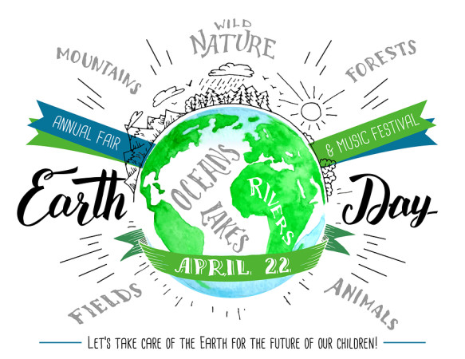

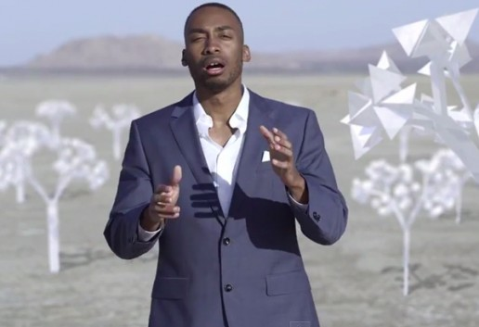 Picture B

Portuguese Team