SUSTAINABLE CONSUMPTION

I. Introduction tasks

1. Put these words in the correct order so as to find back the original quotation.

EVERYBODY EVERYONE EARTH IS

'S BUT THERE ,

'S NEED FOR FOR

NOT ENOUGH ON GREED

Answer: There is enough on earth for everyone’s need but not for everyone’s greed.

Can you find out who said this?

Gandhi

2. a. Write the word “CONSUMER SOCIETY” on the board. Have the students give a definition.

Definition from Cambridge Dictionary:
“a society in which people often buy new goods, especially goods that they do not need, and in which a high value is placed on owning many things”

b. Ask the students to discuss which goods they think are most essential for their lives and they couldn't live without.

c. Brainstorm words and ideas around the word “Consumer society”

Words to be found:
- addicted to, addiction
- discount / sales
- get a bargain
- compulsive spending
- to go on a shopping spree
- brand
- material goods
- crowded / to crowd around

d. Teen spending in North America, by category.
Match the category to its percentage.
Then compare North Americans' spending habits to your spending habits?

Music/movies 1%
Furniture 2%
Food 3%
Events 6%
Video games/systems 6%
Clothing 7%
Shoes 8%
Car 8%
Books/mags 8%
Accessories/personal care 10%
Electronics/gadgets 21%
Other 21%

Answer:

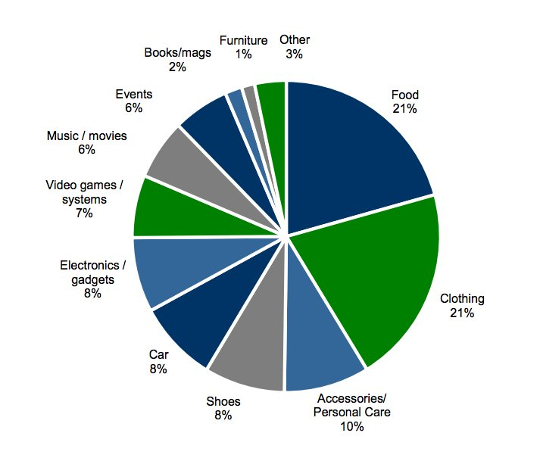
Source: http://www.businessinsider.fr/us/how-teens-are-spending-money-2014-4/
Everything You Need To Know About How Teens Are Spending Money, What They Like, And Where They Shop, Hayley Peterson, 9 Apr 2014, 13:22

- The threats of unsustainable consumption
1. Analyze this picture. Give your opinion on “Black Friday”

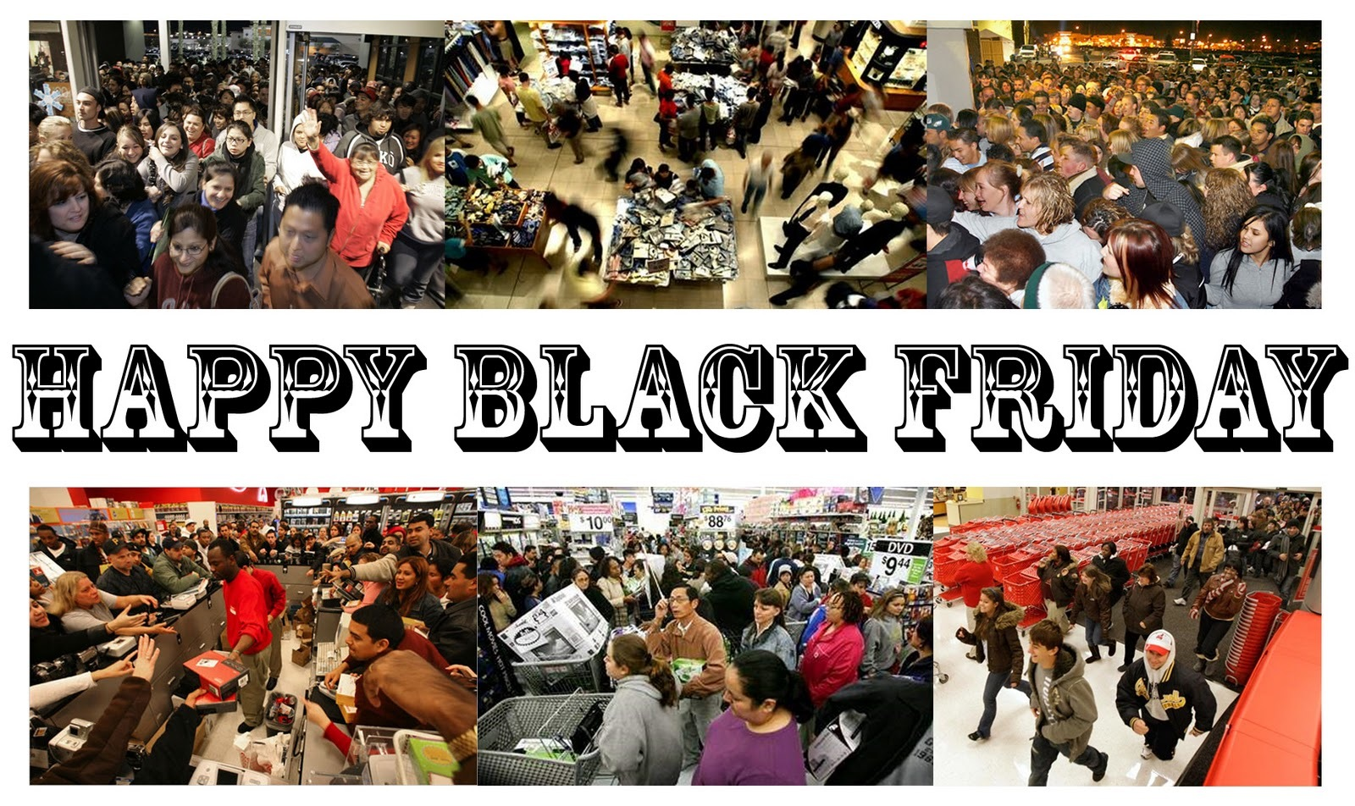
Source: beforeitsnews.com

Black Friday:
The busiest shopping day in the USA, which takes place on the Friday after Thanksgiving and marks the beginning of the Christmas shopping with reduced prices offered to customers.

2. Listening exercise

Black Friday

- Alternative buying
- Reading comprehension

Split the class in 3 groups. Each group will have a different text and will have to fill in their part of the grid and then report to the rest of the class.

Text one: bartering
Text two: freeganism
Text three: fairtrade

- Discuss the three alternatives.

- Compare the three alternatives using the comparative form.
- Which one do you prefer? Why? Use the superlative form.
- Grammar exercise

- Mind map

Make a mind map to recap the whole lesson. The best one will be hung on the walls of the classroom.

- Listening exercise: you're never too young to volunteer

Source: http://www.cbc.ca/manitoba/eal/2008/01/lesson-15-youre-never-too-young-to-volunteer---a-group-of-children-help-out-at-a-food-bank.html

- Final task

Create a LEAFLET for your awareness campaign about over-consumption.
Your leaflet will include:

- striking images
- a presentation of the risks
- a catchphrase and some advice
- details about the movement (name, logo, address) and the organization of a march (place and date)

