Conscious consumers of the future
ERASMUS + project

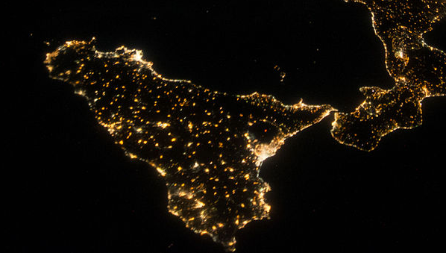

Travel manual: Sicily
Geography

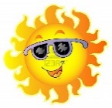Climate and weather: In March, the climate is quite cold and the temperatures are from 6°C to 13°C. The sea is quite warm with a temperature of 15°C. It rarely rains because the climate is quite dry.

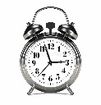Time Zone: The time zone is the same as in France.

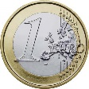Currency: the currency of Italy is the euro.

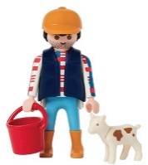Job perspective: Farming and tourism

Must see places: Museum of Chocolate of Modica; archaeological area of Cava d’Ispica; Chiesa di san Giovanni Evangelista; Pizzo Belverdere and many others….
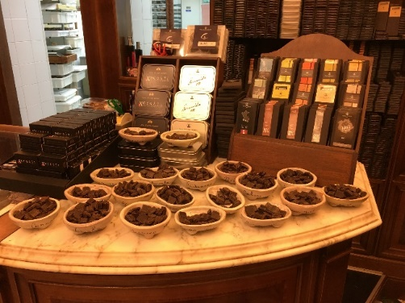 Museum of chocolate of Modica
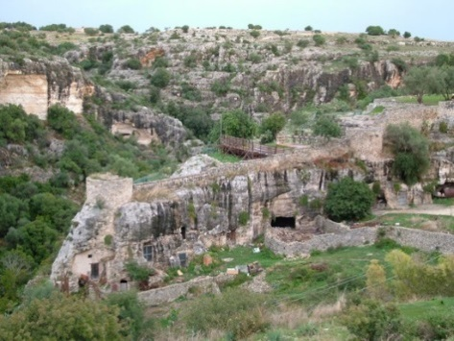 Archaeological area of Cava d’Ispica

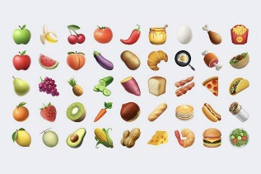Economic activities: The economy of the area is principally agricultural with the production of olives, carrots, vegetables, cereals, and cattle; an extraordinary and unique product is the famous chocolate of Modica, produced with an ancient and original Aztec recipe.

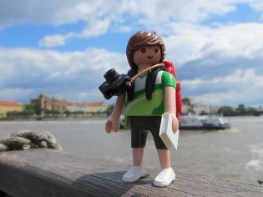Regional economy: Tourism is also an important industry in the area, since Modica entered the UNESCO World Heritage Site in 2002

Famous people in Sicily :

Paolo Borsellino:
Was an Italian anti-Mafia judge. He is the brother of Rita Borsellino, antimafia activist and former president of Libera.
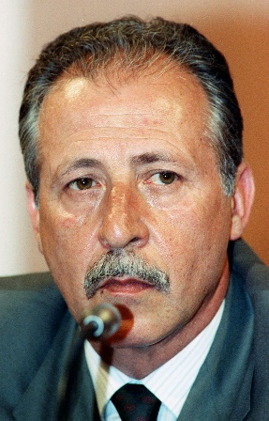

Salvatore Adamo:
Is an Italian-Belgian singer-songwriter who was born in Comiso (Sicily).
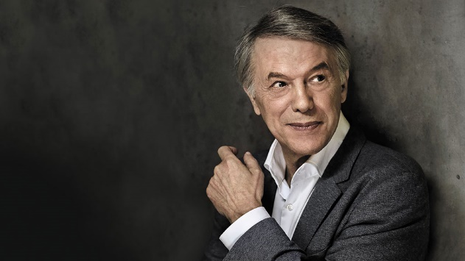

Luca Parmitano:
Is an Italian astronaut, recruited in 2009 during the 3rd selection of astronauts of the European Space Agency. He is a test pilot in the Italian Air Force.
s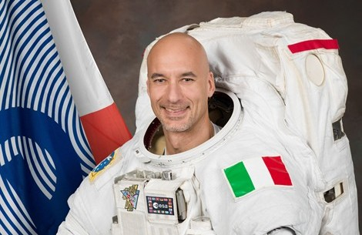
Giovanni Salvatore:
Augusto Augusto Falcone, born in Palermo, was an Italian judge engaged in the struggle against mafia and assassinated.


Personality of Sicilians:
According to the Italians of the peninsula, Sicilians are traditional, distrustful, impassive, God-fearing, self-confident, sociable and thoughtful... and have a malicious sense of humor.
According to the French students, Sicilians are impulsive, have a bad temper, and are generally mafia-like, they scream, talk loudly and with their hands.

Coat of arm of Modica
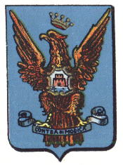
Typical sicilian dishes
Muffuleta
It is composed of salami, mortadella, red pepper, bread and lemon juice.
Buccellatini
It is composed of walnuts, semolina, almonds, walnuts, figs, oranges and raisins.

Arancini
It is composed of breadcrumbs, rice with cooked risotto, cured ham, mozzarella, eggs and flour.

Sicilian Cannoli
It is composed of cocoa powder, pistachios, ricotta and coffee vanilla essence.

Buccellatini
It is composed of walnuts, semolina, almonds, walnuts, figs, oranges and raisins.

