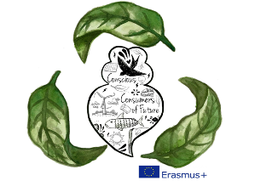

**CONSCIOUS CONSUMERS OF FUTURE**

Lesson plan on unsustainable consumption

Time: 3*45 min

Level: students aged 16-18, intermediate level of B2/B2+ of European framework

Related subjects: English (vocabulary connected to ecology, grammar – unreal past and regrets ), Biology (ecology), Geography (Earth’s waters), Physics/Engineering (inventions for collecting wastes), ICT (making presentation)

Aims: Students will become aware of unsustainable consumption and production, their consequences on the environment and the benefits of sustainable consumption. They will:

* know the basic concepts of unsustainable consumption and the basic principles of sustainable one;
* understand the relationship between production, consumerism, generation of waste and devastation of the environment;
* become aware of the impact on the environment by consumers’ daily choices.
* recognize that everyone contributes to the amount of waste created every day;
* think about ways to become more sustainable consumers;
* think about a future planet based on the main principles of sustainable consumption.

************************************************************

1. discussion on a quotation: *“We know that when we protect our oceans, we’re protecting our future”*  - Bill Clinton
2. <https://www.facebook.com/PlasticPollution/videos/10155236742451479/?t=4>

<https://www.facebook.com/180340042008871/videos/2011232998919557/?t=0>

1. Reading comprehension.

Read the text. Choose the correct option for sentences 1-5 , answer the questions 6-10 and discuss the problems presented in questions 11-13.

CAN A TEENAGE ENVIRONMENTALIST CLEAN UP OUR OCEANS?

Boyan Slats in a young Dutchman with a mission to save the oceans from the consequences of our throwaway society.

The facts.

Oceans cover 71% of the earth’s surface. From the fresh water of the polar ice caps to the seabed eleven kilometers below the surface of the deepest point of the pacific Ocean, the ocean is home to over half of all living species. Over the past 100 years, due to global warming, the sea level has risen to 25 centimeters.

The problem.

The oceans are being used as rubbish tips. 32% of toxic contaminants in oceans come from air pollution such as acid rain and debris blown from landfills. Other pollutants are sewage, industrial waste and pollution from oilfields and ships. The plastic debris concentrates in five rotating currents like giant whirlpools called gyres. The largest gyre, called the Pacific Garbage Patch, is twice the size of France and is located between Hawaii and California. At least one million seabirds, and one hundred thousand marine mammals die each year due to plastic pollution. When plastic breaks up into smaller particles it becomes a hazard for marine wildlife. Seabirds, whales, turtles and other sea creatures regularly consume waste products, which can be easy mistaken for jellyfish or other prey but cannot be degraded in the stomach. The animals die from starvation because they are not getting the nutrients they need. Plastic also slowly release toxins and other chemical substances that work their way up the marine food chain.

A solution.

At the age of 19 Boyan Slat invented a device that he claims could clean up to 20 billion tonnes of plastic waste from the world’s oceans. Unlike conventional methods of cleaning up plastic using ships and nets, Boyan Slat’s “Ocean Clean-up” concept is based on a simple idea: with its waves, tides and currents the ocean never stops moving, so instead of going after the plastics, as most traditional methods do, you could simply wait for the plastic to come to you. A floating barrier 100km in length, would catch the debris, enabling the platform to extract it afterwards. The ocean current could pass underneath the barriers taking all sea life with it. Boyan Slat believes that his innovation could clean up half of the Pacific Garbage Patch over a period of 10 years, and would make up to 50 million dollars a year from recycling the waste collected.

1. Oceans cover *61% / 71%* of the earth’s surface.
2. The deepest point of the Pacific Ocean is *7 km / 11 km* below the surface.
3. Sea levels have risen *10 – 25 cm / 5 – 10 cm* over the last 100 years.
4. Plastic waste *remains / disappears* in the ocean.
5. Plastic pollution kills at least 1 million *seabirds / marine mammals* every year.
6. Apart from plastic, what other things pollute the oceans?
7. What is “a gyre”, how many are there and where is the biggest one?
8. Why is plastic pollution a problem for marine wildlife?
9. How is Slat’s device different from other “clean – up” devices?
10. What two claims does Slat make about the effectiveness of his device?
11. How much plastic does your family throw away in a typical week?
12. Do you know what happens to your plastic waste? Where does it go?
13. What could you do to cut down on your use of plastic?
14. Grammar focuses on unreal past and regrets, using structures: *I wish, if only, it’s high time, I’d rather*. Suggestion – finishing the sentences devotedly to climate problems:
15. I wish I could …………………………..
16. It’s high time I …………………………….
17. I’d rather people didn’t ………………………..
18. If only I hadn’t ………………………….
19. I wish my parents …………………….
20. If only my friends ………………………………..
21. Giving presentation.
22. Selecting a natural wonder that interest you.
23. Do some research and plan your presentation.
24. Find some interesting photos to illustrate the presentation.
25. Choose useful phrases for introducing the topic, familiar information, surprising information, finishing the presentation.
26. Give your presentation to the class.
27. Speaking (for Polish final exams, however, good to use😊 )

You want to take part in an ecological action for your holidays. Look at two options given – choose the one that would be the most appropriate for you and explain why. Also justify why you wouldn’t choose the other one.

 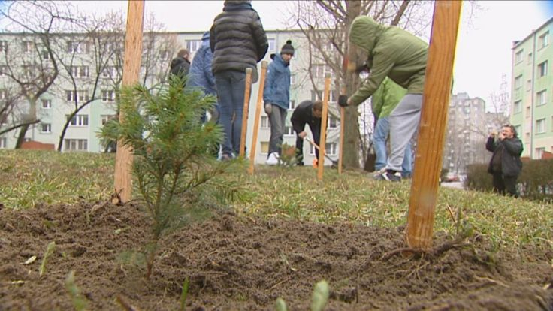

Some additional points to discuss:

* What could be done to persuade more people to recycle more?
* How can you use social media to promote an environmentally friendly lifestyle?
* Is the work of environmental organisations effective? What makes you think so?
* What are the advantages of living next to a large green areas?

**Disclaimer: This project has been funded with support from the European Commission. This lesson plan reflects the views only of the author and the Commission cannot be held responsible for any use which may be made of the information contained therein.**