**Educational progression toward sustainable cooking**

**Contribution to the Erasmus project**

**André PAILLOT high school – European Section 2018-2019**

**Course 1- General talk with students about sustainability**

Sharing facts, concerns, knowledge and representations, actual or possible actions…

As a result, two main topics were identified as key questions for the students:

- Sustainable fashion,

- Sustainable cooking.

**Course 2- Starting from Sustainable fashion**

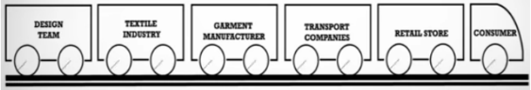<https://www.youtube.com/watch?v=bmnWIOgc39k>

The afore mentioned on-line video is viewed once completely and then commented by the teacher in order to clear potential issues of understanding and help the students raise the key questions. The students are then asked to work on this topic and search all technical or missing vocabulary required to express easily their meaning next time.

**Course 3- Sustainable fashion is discussed with the students**

The video is viewed again, but this time step by step to highlight major ideas, difficult or specific words and let the opportunity to each student to share his contribution.

**Course 4- From Sustainable fashion to hidden costs**

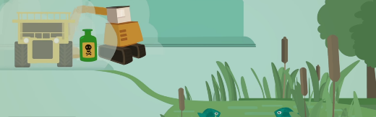The matter of hidden costs was raised by the talk about sustainable fashion.

Same as before: the video indicated below is first viewed as a whole with general comments buy the teacher. The students are asked to get ready for a thorough talk next time.

<http://17goals.org/a-5-minute-video-on-sustainable-consumption/>

**Course 5- The notion of hidden costs is discussed with the students**

The video is viewed again, step by step, in order to show the many aspects and often unsuspected consequences of hidden costs.

**Course 6- Back to sustainable cooking**

Along with fashion, eating and cooking were revealed as crucial topics for teenagers.

This matter of sustainable cooking was addressed by a free talk in class, with the objective of sharing knowledge and ideas from all the students, including the notions raised by the previous two videos about sustainability, as well as each personal feeling regarding food: greedy or not, good cook or without any experience…

The objective is to identify how cooking (and eating), though even more necessary than clothing, can be more or less sustainable. Major challenges are identified, alternative solutions are considered. Again, students soon notice that they often lack vocabulary to express simply but accurately their meaning. So they are asked to lead a personal search to fill this gap until the next course.

**Course 7- Final talk about sustainable cooking.**

The students are asked to present their ideas more completely and more accurately, using the relevant vocabulary. From this material, the teacher and writes the attached **two-page reminder** to browse the key ideas that have been raised and insist on the essential glossary.

**(7b)** **Further questions** were raised by the students and answered by the teacher via e-mail, especially regarding the various means of preservation (some of the students specialized in food processing!). Thus the additional text below:

*- Chilling: cooling down, refrigerate, preserve at a low (but above-zero) temperature*

*- Freezing: storing something at a very low temperature (much below 0°C)*

*- Pickling: preserved in in vinegar, brine (strongly salted water), or a similar solution.*

*- Bottling: keep in tightly closed bottles (without air) a product that was previously sterilized by heat*

*Same principle as canning (in metal tins or glass jars) or other kinds of preserves.*

*- In the case of jam (made from fruits), in addition to sterilization by a high temperature, the preservation is ensured by a lot of sugar. Provided the jar or pot stays hermetically sealed (no air neither microbe can come inside, once sterilized).*

*For completeness, other means of preservation that were not mentioned in the main text, such as* ***dehydration*** *(dried products),* ***lyophilization*** *(freeze-drying),* ***fermentation*** *(sauerkraut, made from cabbage for instance) or even* ***gamma-irradiation*** *(which is strictly regulated, for potatoes, onions…)*

**Course 8- Knowledge assessment**

In a written test, the students are asked to

“*Explain why cooking is a concern in sustainable development*”