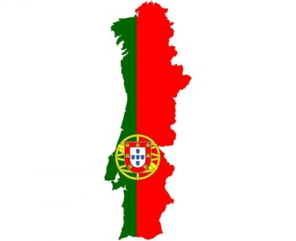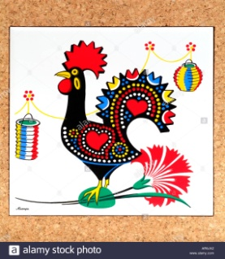

PORTUGAL
TRAVEL MANUAL

- CAPITAL AND LARGEST CITY: Lisboa
- AREA: 92.212 km²
- POPULATION: 10,32 millions (2016)
- DENSITY: 113 sq. km
- GOVERNMENT: a semi-presidential republic
- OFFICIAL LANGUAGES: portuguese
- OFFICIAL TIME: -1 hour

Portugal is famous for its beaches, food and Christian Ronaldo….
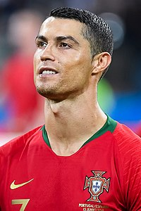

But that’s just the tip of the iceberg.

They are generally known as explorers, thanks to Vasco de Gama, Henry the Navigator and Bartolomeo Dias.
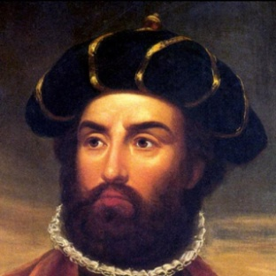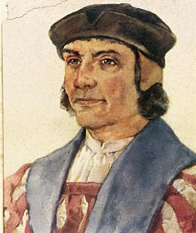

- Portugal is famous for its wine Porto
Famous and unique, Port Wine is a fortified wine produced exclusively in the Douro Region and aged in cellars. Originally it was transported down the river on the traditional Rabelo boats, replicas of which can be seen next to the Luís I bridge. This wine stands out from ordinary wines thanks to its huge range of varieties, with an incomparable richness and intensity of aroma, a long finish, both on the nose and on the palate, and a high level of alcohol content.
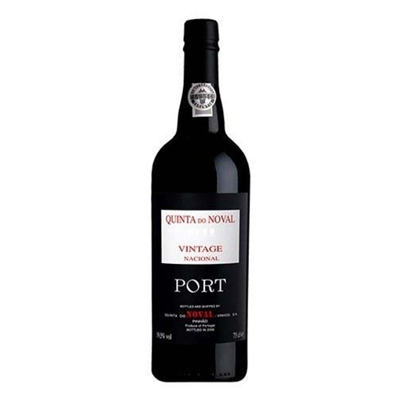

- Portuguese is one of the most spoken languages in the world. Ten million inhabitants of Portugal and also 230million people all around the world speak Portoguese.

• Portugal kicks its traditional image by amazing innovation: The Green Lane Toll pay system is a Portuguese invention, as is the pre-paid mobile phone card. Portugal has experienced the fastest growth in innovation performance among EU member states.
- Portugal is famous for Fado, a form of music which dates back to 1820s. It is profoundly melancholic. The singer sings about the hard realities of daily life, resignation and hopefulness. It can be described by using the Portoguese word “saudade”, which means “longing”, feeling of loss. It is played using one or two guitars and one or two violas. Fado has two main varieties: Lisbon and Coimbra Fado.

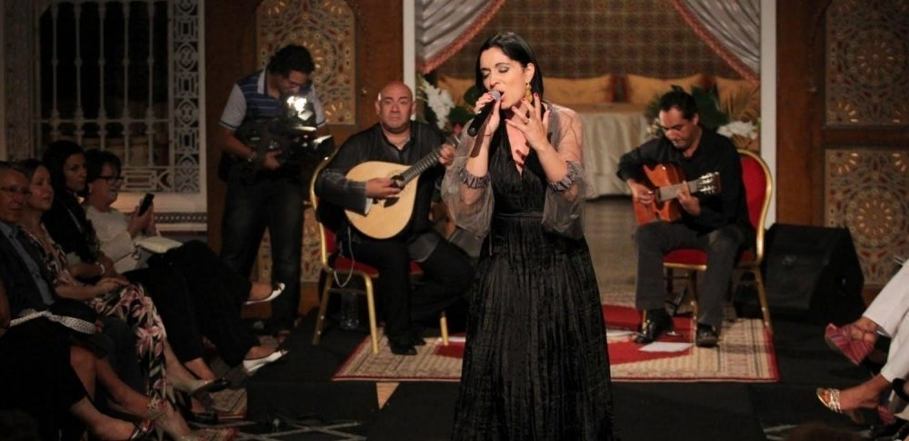

- Portugal accounts for about 50% of the world cork production. The best cork is from Algarve.

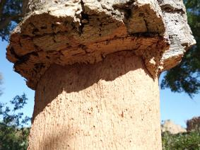

- Portuguese shoes walk the world and strut some of the biggest stages. Rihanna’s 2013 shoe collection was produced in Portugal. Pippa Middleton and her mother both wore Portuguese made shoes for the royal wedding. La Pinta shoes in Algarve is famous for handmade shoes.

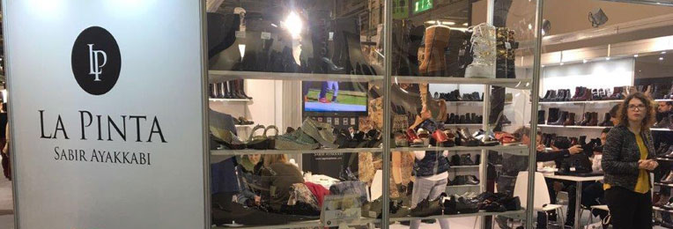

- Some of the biggest and best waves in the world are to be found off the coast of Portugal, at Nazaré and attract surfers from all over the world. Garret McNamara rode the world record wave here in August.

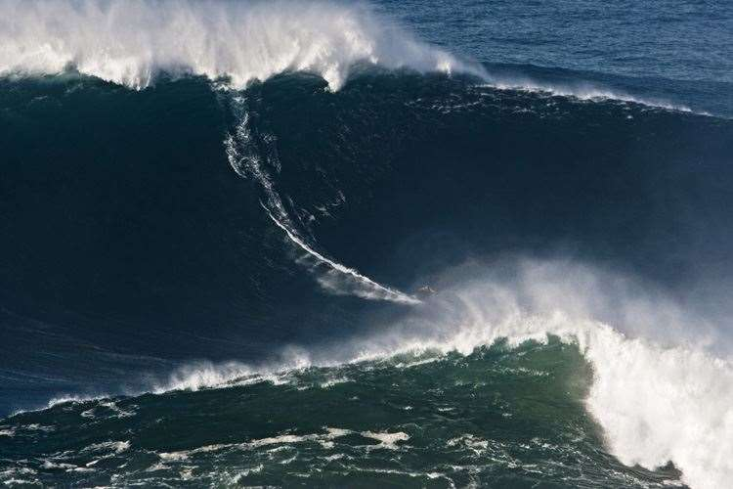

- The Portuguese escudo was the official currency of Portugal until it was fazed out on March 28th, 2002 after the euro was adopted on January 1, 1999. The escudo was divided into 100 centavos (cents). Although the currency is no longer used as a medium of exchange in Portugal, the escudo banknote is still eligible for exchange with the euro until February 28, 2022.
